There are two overall ESG Scores calculated per company, per fiscal year in the model:



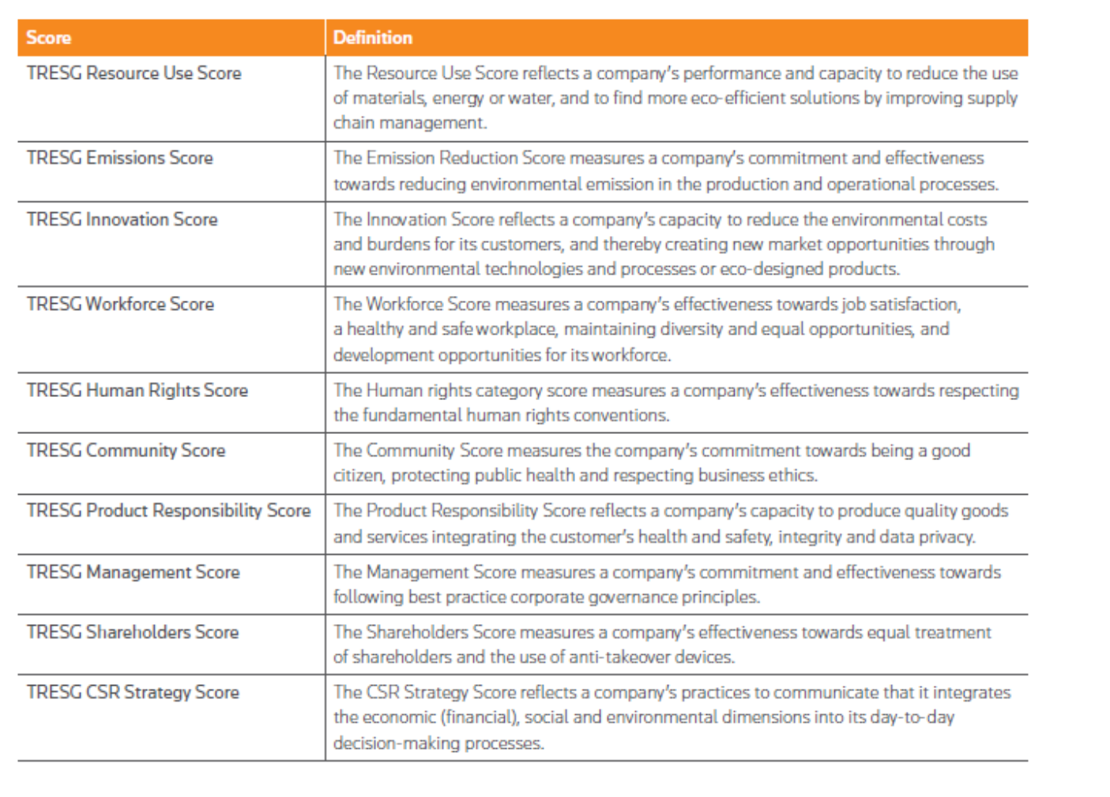

|  |  |  |  |  |  |  |  |  |  |  |  |  |  |  |  |  |  |  |  |  |  |  |  |  |  |  |  |  |  |  |  |  |  |  |  |  |  |  |  |  |  |  |  |  |  |  |  |  |
| --- | --- | --- | --- | --- | --- | --- | --- | --- | --- | --- | --- | --- | --- | --- | --- | --- | --- | --- | --- | --- | --- | --- | --- | --- | --- | --- | --- | --- | --- | --- | --- | --- | --- | --- | --- | --- | --- | --- | --- | --- | --- | --- | --- | --- | --- | --- | --- | --- |
| |  | | --- | | **ENVIRONMENTAL** | | **Resource Use (ejemplos de indicadores)** | | Resource Reduction Policy | | Policy Water Efficiency | | Policy Energy Efficiency | | Policy Sustainable Packaging | | Policy Environmental Supply Chain | | Targets: Water Efficiency, Resource Reduction, Energy Efficiency | | **Emissions (ejemplos de indicadores)** | | Policy Emissions | | Targets Emissions | | CO2 Equivalent Emissions Direct, Scope 1 | | CO2 Equivalent Emissions Indirect, Scope 2 | | CO2 Equivalent Emissions Indirect, Scope 3 | | ISO 14000 or EMS | | **Innovation (ejemplos de indicadores)** | | Environmental Products | | Eco-Design Products | | Renewable/Clean Energy Products | | |  | | --- | | **SOCIAL** | | **Workforce (ejemplos de indicadores)** | | Policy Employee Health & Safety | | Policy Supply Chain Health & Safety | | Policy Skills Training | | Policy Career Development | | Policy Diversity and Opportunity | | Targets Diversity and Opportunity | | Women Employees/ Women Managers | | Flexible Working Hours | | Employees With Disabilities | | **Human Rights (ejemplos de indicadores)** | | Human Rights Policy | | Policy Freedom of Association | | Policy Child Labor | | Policy Forced Labor | | Policy Human Rights | | **Community (ejemplos de indicadores)** | | Policy Fair Competition | | Policy Bribery and Corruption | | Policy Business Ethics | | OECD Guidelines for Multinational Enterprises | | Corporate Responsibility Awards | | **Product Responsibility (ejemplos de indicadores)** | | Policy Customer Health & Safety | | Policy Data Privacy | | Policy Responsible Marketing | | Policy Fair Trade | |

|  |
| --- |
| **GOVERNANCE** |
| **Management** |
| Board Functions Policy |
| Corporate Governance Board Committee |
| Compensation Board Committee |
| Board Structure Policy |
| Policy Board Size |
| Policy Board Independence |
| Policy Board Diversity |
| Number of Board Meetings |
| Board Gender Diversity, Percent |
| Board Member Compensation |
| **Shareholders** |
| Shareholder Rights Policy |
| Policy Equal Voting Right |
| Veto Power or Golden share |
| Limitation of Director Liability |
| **CSR Strategy** |
| CSR Sustainability Committee |
| CSR Sustainability Reporting |
| GRI Report Guidelines |
| CSR Sustainability Report Global Activities |
| CSR Sustainability External Audit |
| CSR Sustainability External Auditor Name |
| ESG Reporting Scope |